FIT5152 User interface design and usability

Prototyping Assignment

|  |  |
| --- | --- |
| Name | ID |
| Lyric Hassan | 30118832 |
| Arvind Yogesh Attur Ramesh. | 29825660 |

Table of Contents

Introduction 1

Paper-based prototype: 1

Sign-Up Form 1

Multicriteria search for friends: 2

Digital-based prototype: 3

1. Login Screen: 3

2. User Profile 4

3. Home/main Screen: 5

4. Multi-Criteria Search for friends 7

5. Reports 8

6. Maps Screen: 9

Appendix 10

References: 11

# Introduction

This report shows user interface design of Monash Finder App in form of paper based and Digital prototyping. Basically, there are six main screens in Monash Finder APP. Paper based protype is used for Two Screen, sign-up form and search screen and for the other including this two is used for digital prototyping. From paper based to digital prototyping there were some improvement which also shown in the report.

# Paper-based prototype:

Sign-Up Form

Figure: a.1

Figure: Refined sketch a.2

The user profile or sign up form is basically used by the new user to Register. In here they had to put various information which would help to find the perfect friend they want to ***(figure: a.1, figure: Refined Sketch b.2)***

Improvement:

As an improvement, two changes are implemented on “Sign-Up” screen at the time of implementing digital prototyping.

1. Use of Icons: In the paper-based prototype there was no Icon used for user flexibility. But in Digital prototyping Several Icon has been used for digital prototyping. The delete Icon and the search Icon is used to provide user more flexibility. It will help user to fill up the from more efficiently.
2. Dropdown option: In paper-based prototype we used dropdown option only for date, month and year but in digital prototyping we have increased the Drop-down option. The Drop-down option used for faculty name, Course name and Favourite unit to find the Existing Data easil

## Multicriteria search for friends:

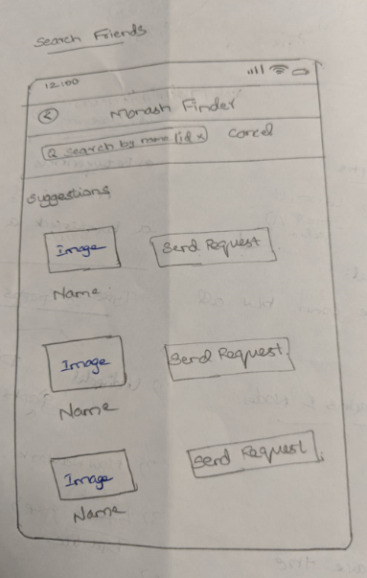 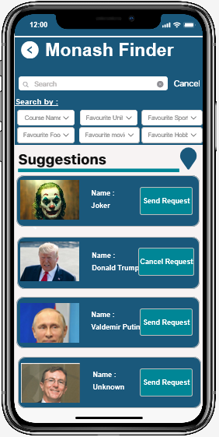

Figure: b.1

Figure: Refined sketch b.2

The multi criteria search for friend’s screen is mainly used to search friends within the Monash University to connect. In (***figure****:* ***b.1)****,* Here, in search box, user can search friends using names/id. It also displays friends’ details with profile image, name and “send request” button to send request.

***Improvement:***

As an improvement, two changes are implemented on “Search Friends” screen at the time of implementing digital prototyping.

1. The search criteria are improved on “Search Friends” screen (***figure: Refine sketch b.2)***. In addition to “Search friends by name/id”, few searches are implemented based on “Search by course name/Favourite Unit/movie/sport/hobby” to get matching friends.
2. In second change, the profile image and name of each friends displayed in the friend list are placed adjacent to each other (***figure: Refine sketch b.2)***. This is because. Generally, human’s eye scans a screen in Z-pattern (left to right). Therefore, placing image on the left side of the screen will catch user’s eye to see the matching friend’s image.

# Digital-based prototype:

## Login Screen:

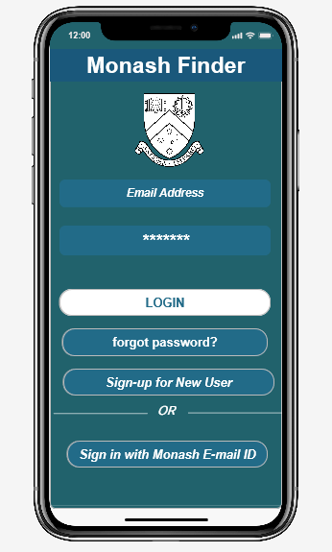

Figure 1.0

The “Login Screen” (figure:1.0) is an initial screen of the “Monash Friend Finder” mobile-based application which guides user to the home screen. This form allows the user to enter email address and password to sign-in to the application.

* “***forgot password?***” button to change password.
* “***Sign-up for New User***”.to create profile. This button takes the user to “User Profile” (***figure: 2.0***) page to enter necessary information.
* “***Sign in with Monash E-mail ID***” button is used to sign in with Monash email-id and password.

The “Login Screen” (***figure: 1.0***) has been built based on following guidelines:

* 1. ***Replace horizontal labelling by vertical labelling:*** Generally horizontal labelling used in web application to display email address, password and other possible inputs. Since, “Monash Finder App” is a mobile-based application, as per the mobile design guideline, it is better to use vertical labelling than horizontal labelling for display user inputs that improves the user’s inconvenience. It also helps the user to view the screen with vertical labelling and reduces unwanted space. In ***figure:1.0*** the buttons, labels are placed vertically so that it is also compatible to the mobile screen.
  2. ***Keep the input fields to the minimum and combine similar input fields:*** As per this guideline, in Login Screen (***figure:1.0***), the minimum input labels are used to make the screen concise that gives idea and attraction to user on how application works. Therefore, the login screen landed up only with important and relevant inputs.
  3. ***Eliminate redundant and less important entries:*** As per this guideline, login screen (***figure:1.0***) is designed by eliminating the redundant entries such as "confirm email", "confirm password" to keep the mobile page consistent and ease to use for the users. This screen helps the user with improved user interface and designed with important and relevant entries.

## User Profile

Figure 2.2

Figure 2.1

The user Profile Screen/Sign-Up form allows new user to register their account to use Monash Finder App. So, users must input all the information needed to create their account successfully. This information also helps Monash student to search friend successfully. To build user profile several guidelines have been used which are described below:

* 1. ***Affordance & Signifier***: By looking at the hint text of Sign-up form, one can easily understand data he/she needs to input to fill up the form. The hint text is used to reduce the clutter in the Screen and helps user to understand what data is required. *Signifier* is also used which help user to understand what it can do (Norman, 2013). There are several Icon signatures used in user profile to make registration convenient for the user such as the cross sign of each user input help user to delete their text input easily ***(figure: 2.0 & 2.2).*** So, the affordance and signifier help user to fill the form easily (***figure:2.1***).
  2. ***Good Error Message:*** The Monash finder app is for Monash student which require Monash email-ID to open account, but if student input wrong e-mail ID then one simple solution to remove error is to trap error when they occur and inform user (Maglio Paul, 2004).So if a user doesn’t input the Monash-email address it will provide an error message to user to input correct email-ID.
  3. ***Logical Grouping of related items:*** The input data in the user profile or sign-up form is logically organised. The first name and Last name is in the same row and then all data about the user favourite thing is given next. The email-ID and Password to create an account is in the bottom page. Every item in the page is logically grouped and structured for the simplicity for user

## Home/main Screen:

The (***figure: 3.0***) is the home screen of “Monash Friend Finder” App. User logs into the Home screen with correct credentials ***(figure: 3.0).*** As this is the primary screen to interact with all other screens, it should be attractive and ease to use even by the naïve users. In “Monash Friend Finder” app, the home screen (***figure: 3.0***) attracts user by showing what the application does and all its key feature in a single form.

At the top level of this home screen, the application displays the name, the current date, time and temperature, user profile picture with name so user can confirm that he/she logged in with their correct credentials. Guidelines followed in designing this home screen ***(figure 3.0)*** are,

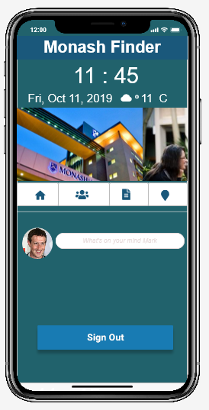

Figure 3.0

* 1. ***Be consistent in using (icons, text labels or both):*** The Home Screen (***figure 3.0***) provides certain features such as “***Searching Friends***”, “***Reports***”, “***Maps***” but in (***figure 3.0***), these features are displayed as icons instead of labels. As per the *Tab Menu Design guideline*, for displaying menus, it is better to use concise icon rather using words to describe that terminology. Using icons for this feature reduces the space and attracts the user by identifying what does that exact icon means and describe its terminology.
  2. ***Do not use long labels:*** This guideline is like the above *guideline:3.1.* In Home screen (***figure:3.0***), the feature of “Monash Finder App” are not displayed as long labels. Therefore, icons used for each feature identifies what it exactly does and adding intuitive effects on the icon improves the superiority of menu icons (Kim, 2011)

|  |  |
| --- | --- |
| ***Home Screen Icon*** | ***Feature*** |
|  | Icon resembles home screen of “Monash Finder App” |
|  | Icon resembles” Search Friends” feature, it takes user to search friend screen (***figure:4.0***) |
|  | This icon resembles “Reports” feature. It takes the user to “Report” page screen (***figure: 5.0***). |
|  | This icon resembles “Maps” feature. |

* 1. ***Recognition rather than recall:*** As per the Nielson’s guideline, the home screen (***figure 3.0***) provides certain features that can be easily recognised by its icon so that user do not need to recall. The below table defines what each icon denotes to,

|  |  |
| --- | --- |
| ***Home Screen Icon*** | ***Feature*** |
|  | Any user can recognise, it denotes “Home” |
|  | Any user can recognise, it denotes “Search Friends” |
|  | Any user can recognise, it’s related to notification or “Report” |
|  | Any user can recognise, it denotes “Maps”. |

## Multi-Criteria Search for friends

This page allow user to find their Monash friend according to different Search criteria such as course name, favourite sports/ movie /Hobby. Suppose if user choose all the criteria to find friends then a friend who matches with most criteria appears first with name and profile image User can send request by clicking “Send Request” (***figure 4.0***). the guideline that has been user to design this page is given below:

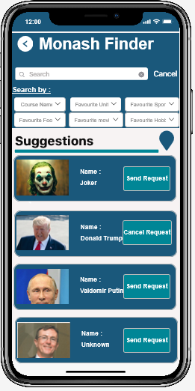

Figure: 4

* 1. ***Proper use of colour in designing materials:*** The colour in this page matches with all Monash finder App pages along with Monash university theme. The dark blue colour used to create hierarchy of friends attract user to see each suggested friend. The different colour of send request button other than the dark blue colour used in the screen (***figure 4.0***) capture users’ attention specifically to send request to a friend. The white text colour in this dark blue screen help user to identify text usually. So, the proper use of colour help user to use the search screen properly.
  2. ***Provide Feedback:*** Feedback communicates the result of action (Norman, 2013). In the search Screen when user search and send friend request, user must know that the friend request has been sent. To provide this Feedback, the send request button will turn into cancel request button to provide information that the request has been sent and now the user can cancel the request if they want to. So appropriate feedback is used in this search screen.
  3. ***Support internal ‘locus of control’:*** This is one of the eight golden rules (Shneiderman, 2014) that has been followed in this entire search page. It provides user more flexibility and option. User can search their friend by name or email-id using search option. They would also be able to search their friend by using various filter such as course name, favourite food/movies and application lists friends among this list to send request. Therefore, it gives user complete locus of control on the search page.

## Reports

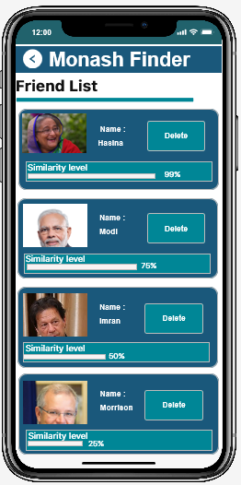 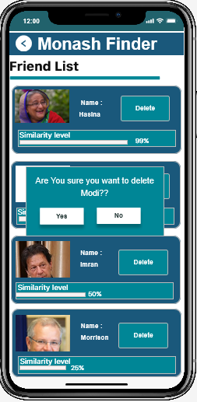

Figure 5.1

Figure 5.2

The Report Screen shows the list of Friend with their name and picture (Figure 5.0). It will also show the similarity level of the user and their friend. The similarity level depends on the matching criteria such as favourite food, movie or courses between user and his/her friend in percentage. In here, user can delete any friend he/she wants to delete.

* 1. ***Visibility of system status:*** Providing user with useful and meaningful feedback about the system is one of the Nielsen’s 10 Heuristic rules and this rule is specially followed in this report screen. In the report screen the similarity level is shown in bar and in percentage. By looking at the similarity bar users would be able to easily understand how much similarity they have with their friends.
  2. ***Use of Hierarchy:*** In the report screen the friend which has the most similarity appears first. Friends in the report screen appears according to similarity percentage. This Hierarchy help user to quickly differentiate the similarly level of his/her friend.
  3. ***Confirmation of action:*** User can delete any friend from the friend list. But if the user mistakenly deletes a friend then user can send friend request again. To save user from this hassle the system will confirm before deleting a friend ***(figure 5.1).*** This help user to confirm their action. If user mistakenly presses the delete button, they can undo it by pressing no in the confirmation message ***(figurer 5.1).*** This gives user better flexibility to use the report screen conveniently and efficiently.

## Maps Screen:

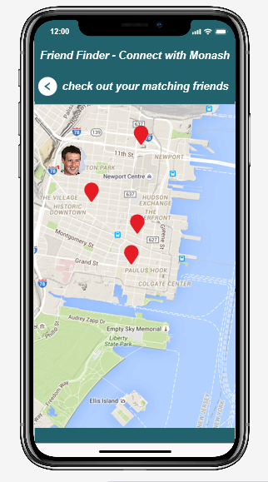 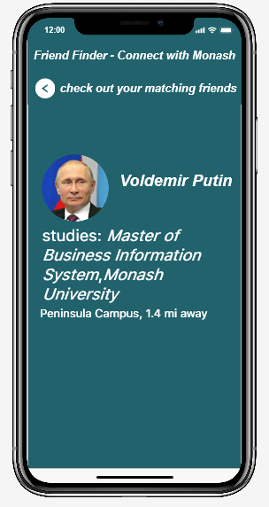

Figure 6.1

Figure 6.0

“Monash Finder App” helps the users to find nearest matching friends using maps. ***Figure 6.0*** shows maps with marker overlays. User can go to the “Map” screen by clicking map icon in the “Home” screen. When clicking on any of this red marker overlay, application takes logged in user to the ***figure 6.1*** which displays respective user profile information. The guidelines that are followed in developing the Map screen (*figure 6.0 & figure 6.1*) are described below,

* 1. ***Provide an easy option to go back and return to the main menu:*** Once user navigates from “Home” screen to “Map” screen, application should not confuse user to return to the actual screen. Some easy way must be given and recognised by the user. Therefore, *left-arrow button* in “Map” screen (***figure 6.0***) obeys the *menu design guideline* andprovides an easy option to return to the main menu. Similarly (***figure 6.1***) shows left-arrow button on top-left corner of the screen to go back to “Map screen and satisfies the guideline. This navigation control allows users to undo any accidental or unwanted touches (Wang, 2012)
  2. ***Meaningful grouping of items:*** In "maps" screen, the items on the marker overlays are grouped and differentiated based on its appearances.In “Map” screen (***figure 6.0***), the profile image of the logged in user denotes that user's locationand Maps with red marker overlays denotes the nearest matching friends of that logged in user. Even though, all denotes user’s location, the items are grouped logically and makes user to understand and find differences between the marker overlays.
  3. ***Provide different navigation for items:*** The "maps" screen (***figure 6.0***) provides different navigation option for the logged in user.
* *Left-arrow button* ("<") on top-left of the screen is a navigation option that helps user to go back to the home screen.
* The "red marker overlays"  on the map marker also the navigation option that helps users to click and view the respective matching friends’ information.

# Appendix

Top-level view of the “Monash Friend Finder” app:

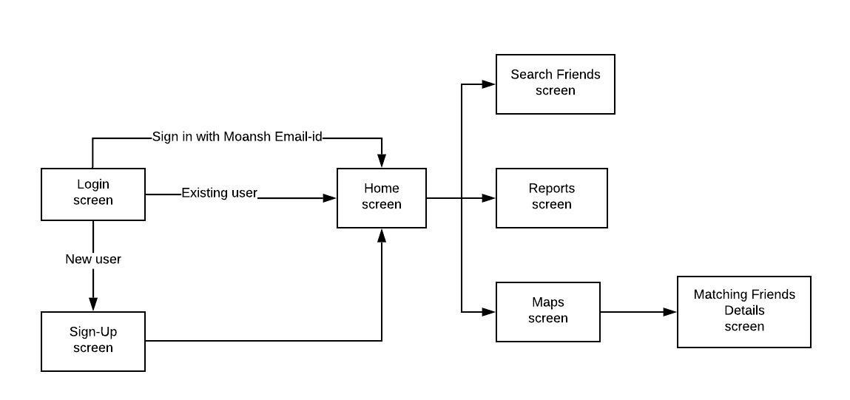

# References:

*Image*. (n.d.). Retrieved from https://encrypted-tbn0.gstatic.com/images?q=tbn%3AANd9GcR-JvocwNhxjvJYprJXdFseseuH2dDPqPBTGdP4oRbHlnPUttUf

*Image*. (n.d.). Retrieved from https://encrypted-tbn0.gstatic.com/images?q=tbn%3AANd9GcRMQgnwa6aN-RcdVMcldZWKf4IeKlY3WvB7xivFdLlZ8TsAD8ZO

*Image*. (n.d.). Retrieved from https://encrypted-tbn0.gstatic.com/images?q=tbn%3AANd9GcTZIXVZUSyfvpFKFu4g38_N5CLl9yexP92qyGbF8VBMoK4mIgqi

*Image*. (n.d.). Retrieved from https://encrypted-tbn0.gstatic.com/images?q=tbn%3AANd9GcS0G81iWDtdMLDd3QLUSho3QiNGBcerEbQCEunqPVONyG1EXuq5

*Image*. (n.d.). Retrieved from https://upload.wikimedia.org/wikipedia/commons/9/98/Vladimir_Putin_%282017-07-08%29.jpg

*Image*. (n.d.). Retrieved from https://encrypted-tbn0.gstatic.com/images?q=tbn%3AANd9GcQlOlIbvrt7vJLWWHorkvI0jEdTw7hHabUaphLLg5ZyuRwYzHXN

*Image*. (n.d.). Retrieved from https://encrypted-tbn0.gstatic.com/images?q=tbn%3AANd9GcTZfvnwgN9QchjsQh7MsyHarjzYOFttbhS0OeKKndxUdTvzzE0Q

*Image*. (n.d.). Retrieved from https://encrypted-tbn0.gstatic.com/images?q=tbn%3AANd9GcQLcidOGQOKByxncW2vW3waYIkzmE4C7sc77w9b2EQsVs4SAR7M

*Image*. (n.d.). Retrieved from https://encrypted-tbn0.gstatic.com/images?q=tbn%3AANd9GcS2DtilQhB8JS-NbJMX1qawqcgh1ZjASdtxDJIhj-SsouRapVFa

Kim, K. (2011). *Derivation and evaluation of 3D menu designs for Smartphones.* Retrieved from https://search-proquest-com.ezproxy.lib.monash.edu.au/docview/905157321?accountid=12528

Maglio Paul, M. P. (2004). Error Messages: What's the Problem? *Queue Vol.2(8)*, 50-55.

Norman, D. (2013). *The Design of Everyday Things.*

Shneiderman, P. C. (2014). *Designing the User Interface: Strategies for Effective Human-Computer Interaction, Pearson.*

Wang, Y. (2012). *Designing restaurant digital menus to enhance user experience.* Retrieved from https://search-proquest-com.ezproxy.lib.monash.edu.au/docview/1270386628?accountid=12528